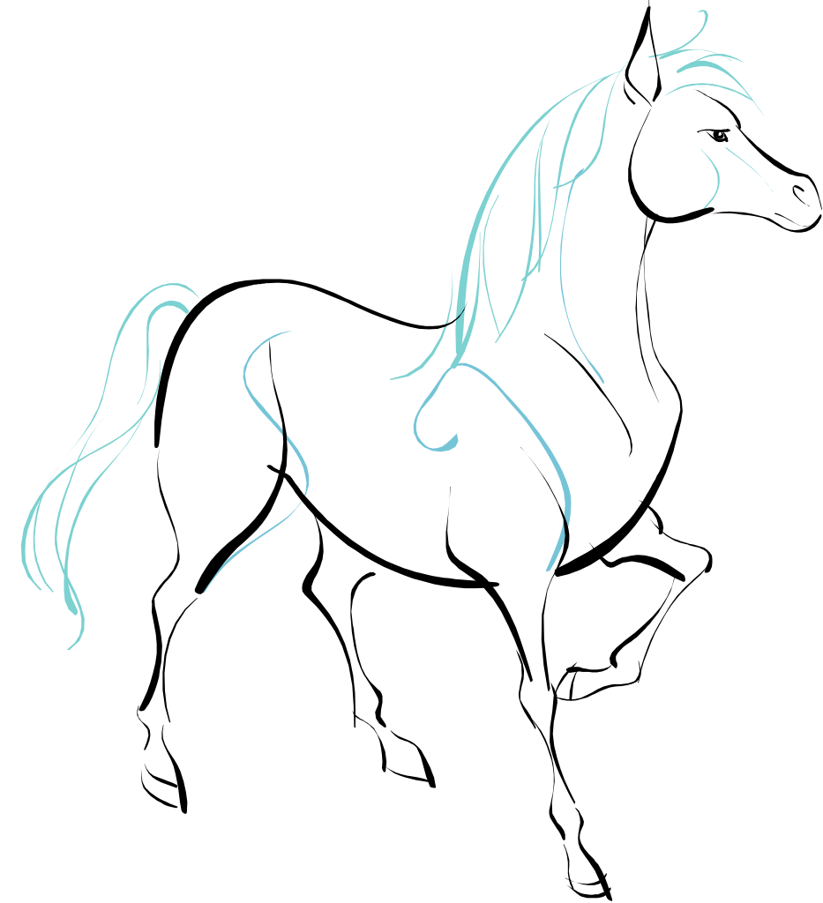
WHITE HORSE BEACH ASSOCIATION
Summer 2015

We have a lot of events planned. The success depends upon your participation, so please plan on attending and lending a hand. If you would like to help organize an event please let us know. Please use the attached form for your dues and to order WHBeachwear.

Don't forget to visit www.whbeach.com for all our information!

Regards,
Phil et al

CALENDAR OF EVENTS

June 27th, 10 AM

"Kickoff" Association Meeting (Jim McNamara's Yard, Abington Ave.)

July 4th, 9 AM

Beach Clean Up

July 11th

WHBA Golf Tournament (Crosswinds Golf Club)

July 25th

The Sandcastle Contest

August 8th

Family Fun Day

August 29th

End of the Year Meeting (Time & Location TBD)

Dues are $90.00 per family this year due to our rising expenses.

Please make checks payable to the WHB Association. We are asking you to complete the ENCLOSED dues form and please mail it in. We need everyone’s dues as soon as possible to be ahead of the game with stair fund and social.
We would like to make sure our mailing/email list is up to date. We really want everyone to come to this meeting and become informed about all of the issues we had this winter regarding our beach!

WHITE HORSE BEACH ASSOCIATION DUES
$90.00 per family per year

NAME_____________________________________________________

Winter Address__________________________________ ___________

CITY___________________________STATE______ZIP_____________

PHONE_____________________________________

EMAIL ADDRESS____________________________________________

BEACH ADDRESS____________________________________________

BEACH PHONE______________________________________________

Please make checks payable to the WHB Association mail to:

White Horse Beach Association
P.O. Box 423
White Horse Beach, MA 02381

WHITE HORSE BEACHWEAR

ITEM | Color | SIZE | COST | Qty | TOTAL
Adult tank tops |  |  | $13.00
Kids T shirts |  |  | $10.00
Adult long sleeve T shirts |  |  | $20.00
Koozies |  |  | $3.00  (2 for $5)
Annual Dues |  | One | 90.00
TOTAL DUE |  |  |  |  | $

NAME________________________________ PHONE_______________

ADDRESS__________________________________________________

Make all checks payable to the WHB Association. Please mail this form please to P.O. Box 423 White Horse Beach, MA 02381

